Daniel Lara - ID: 49651280

Zachary Hart – ID: 70953123

CS 132

HW 2: Wireshark Labs

# Question 2: Wireshark Labs

## DNS:

1. Locate the DNS query and response messages. Are then sent over UDP or TCP?

**Answer: Both the query and the query response use UDP**

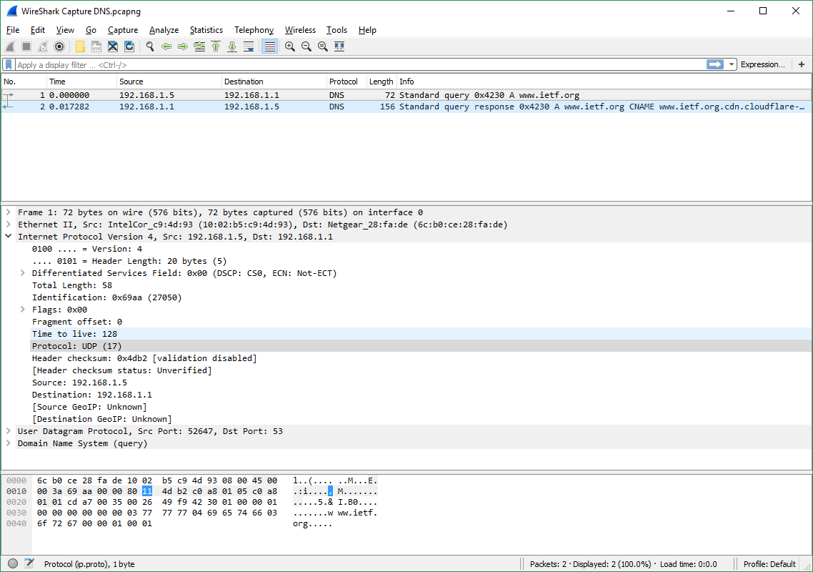



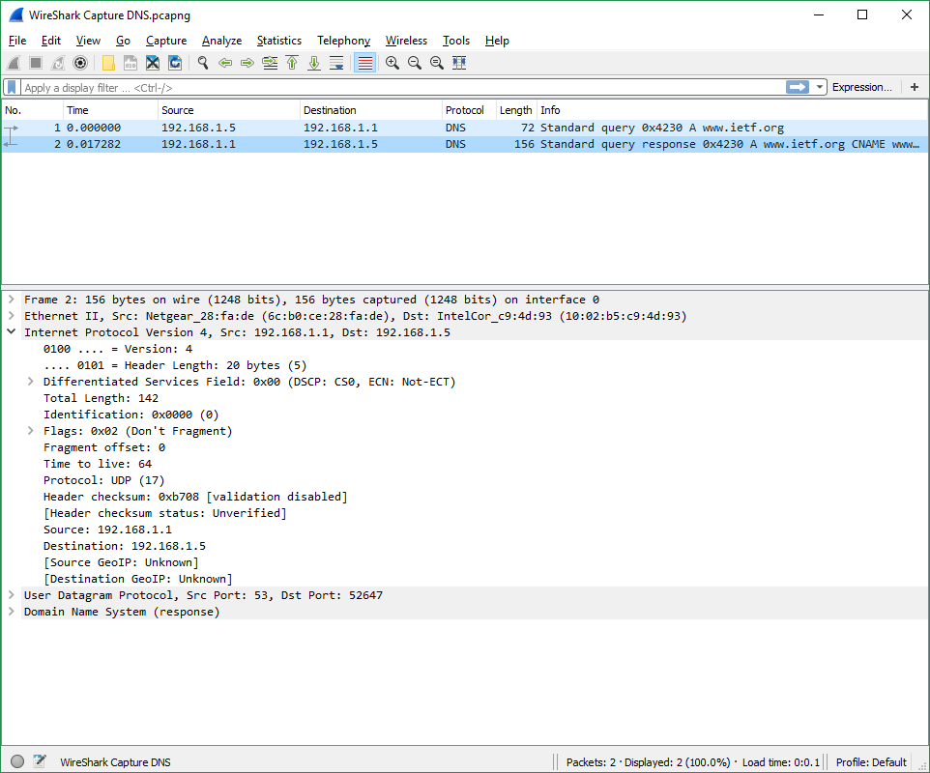



1. What is the destination port for the DNS query message? What is the source port  
   of DNS response message?

**Answer: Destination Port = 53 and Source Port = 53**

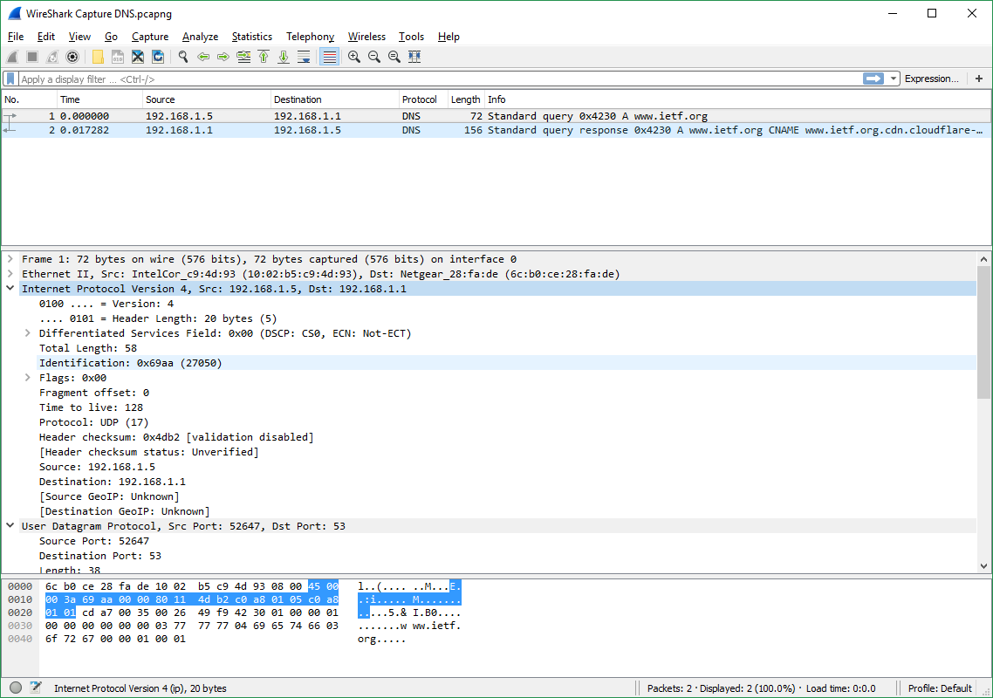



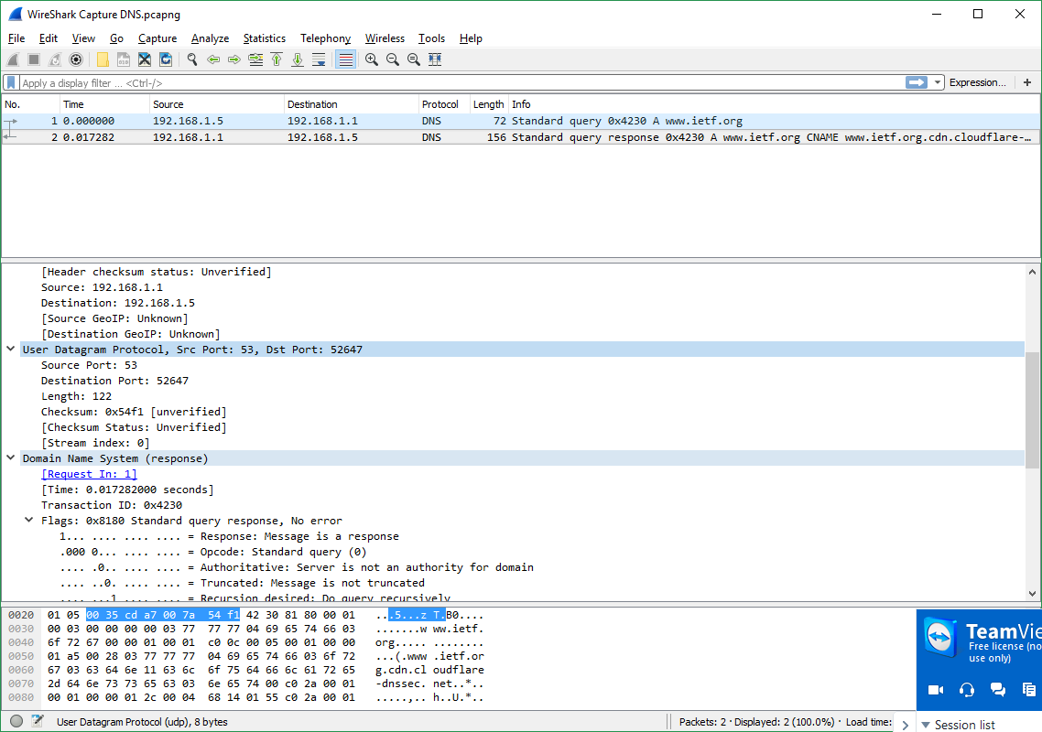



1. To what IP address is the DNS query message sent? Use ipconfig to determine the  
   IP address of your local DNS server. Are these two IP addresses the same?

**Answer: IP Address = 192.168.1.1 | Local DNS server IP Address = 192.168.1.1 (Local DNS was found using the command “ipconfig /all”**

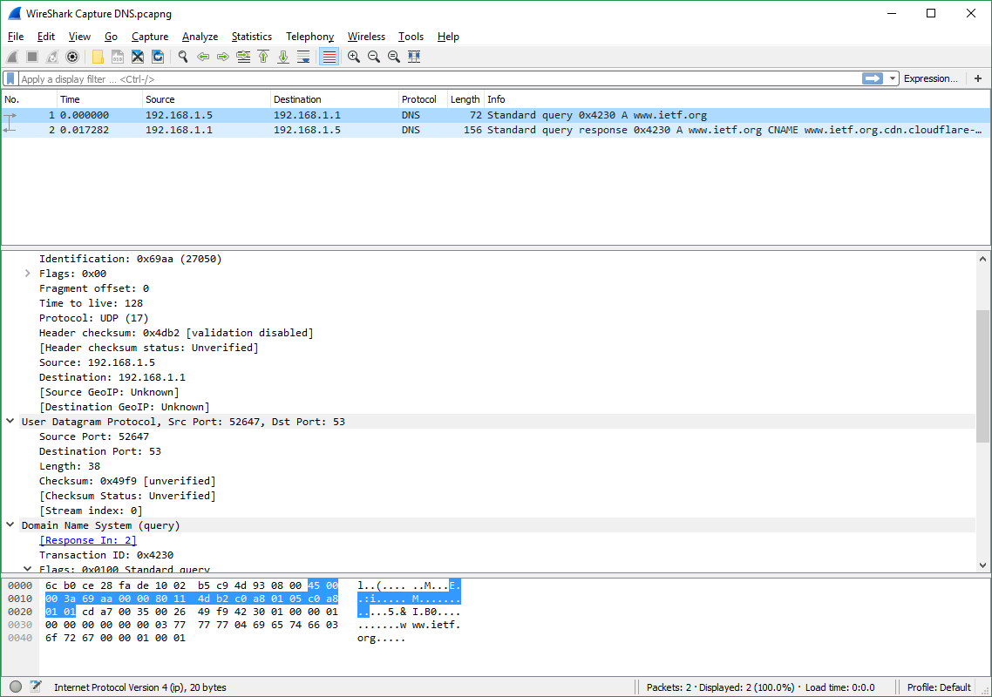



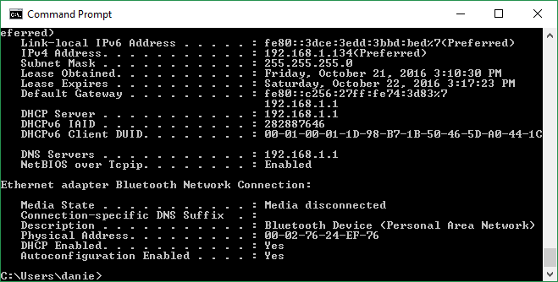



1. Examine the DNS query message. What “Type” of DNS query is it? Does the  
   query message contain any “answers”?

**Answer: Type-A, class IN. The Query message does not have any answers associated with it.**

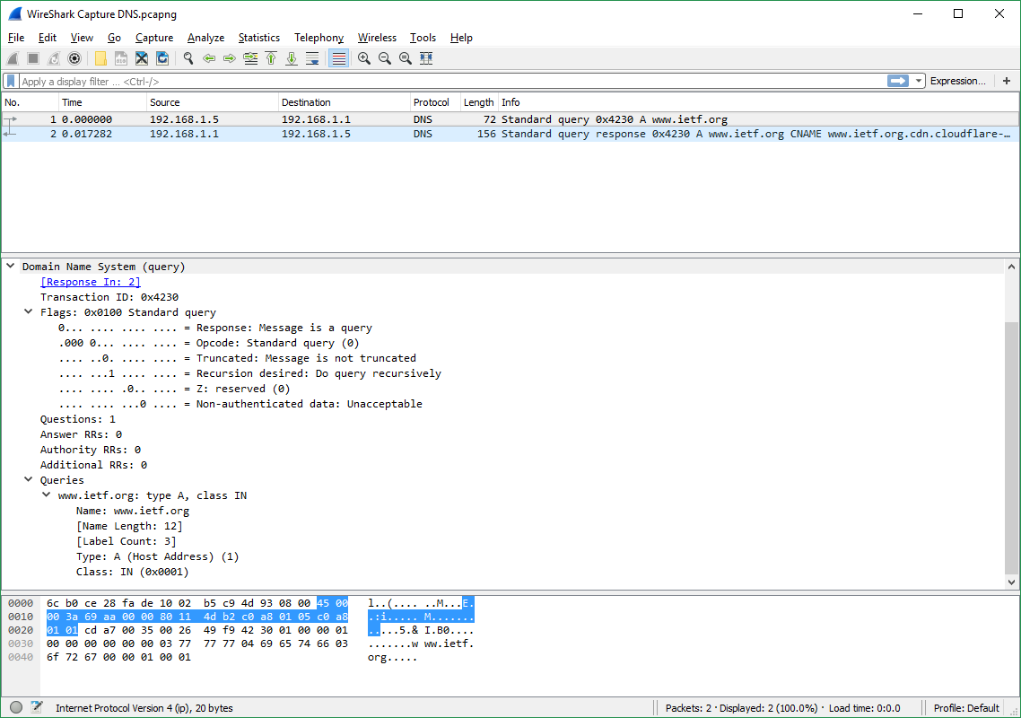



1. Examine the DNS response message. How many “answers” are provided? What  
   do each of these answers contain?

**Answer: There were 3 answers provided. All of the answers have the following: Name, Type, Class, Time to live, and Data length. The first answer is of type “CName” and its value is** [**www.ietf.org.cdn.cloudflare-dnssec.net**](http://www.ietf.org.cdn.cloudflare-dnssec.net)**. The other two responses are of type A and have addresses associated with them. (2nd: 104.20.1.85, 3rd: 104.20.0.85)**

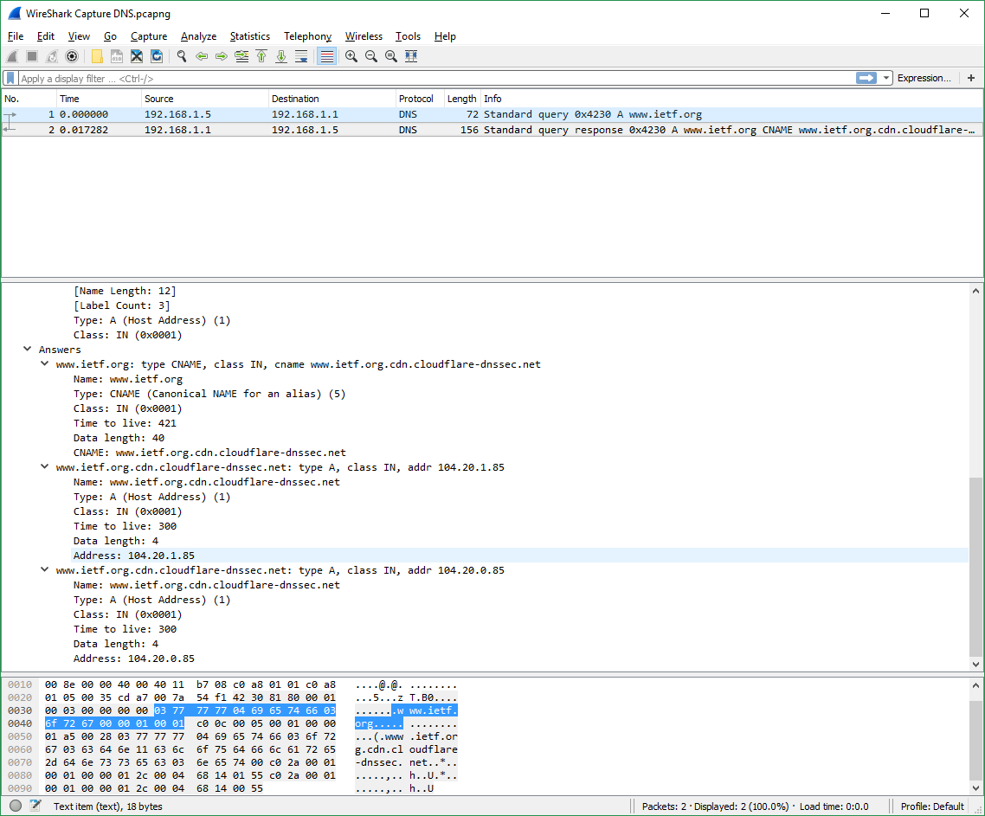



1. What is the destination port for the DNS query message? What is the source port of DNS response message?

**Answer: The destination port in the query message is 53. The source port of the response message is 53**

1. To what IP address is the DNS query message sent? Is this the IP address of your default local DNS server?

**Answer: The IP address is 192.168.1.1. This is the same address as the local DNS server (found by using ipconfig /all).**

1. Examine the DNS query message. What “Type” of DNS query is it? Does the query message contain any “answers”?

**Answer: The DNS query message is type A, it does not contain any answers.**

1. Examine the DNS response message. How many “answers” are provided? What do each of these answers contain?

**Answer: The response message contains 3 answers. Each answer contains a name, a type, a class, time to live, data length, and either an address (if type A) or a CNAME (if type CNAME).**

1. Provide a screenshot.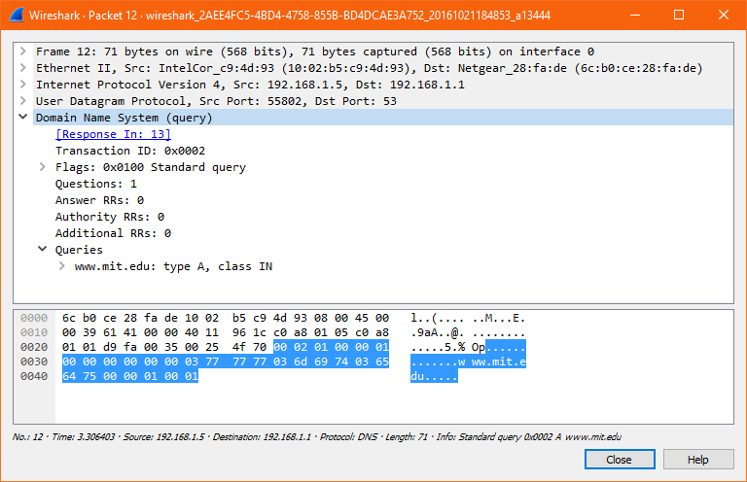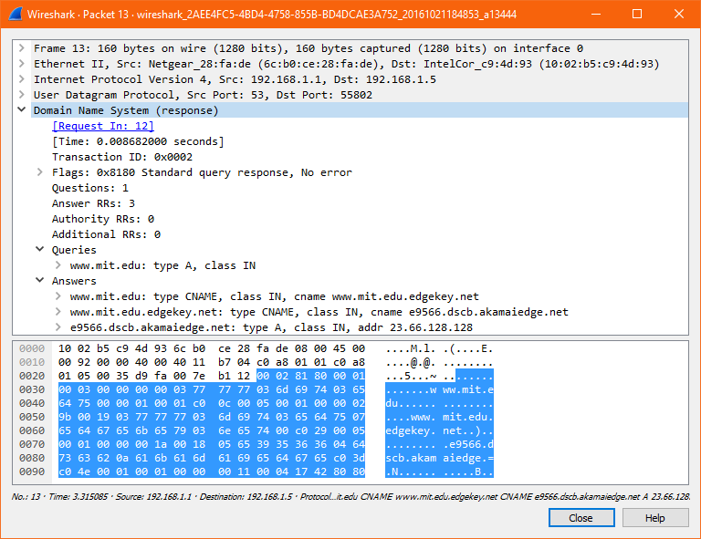
2. To what IP address is the DNS query message sent? Is this the IP address of your default local DNS server?

**Answer: The IP address is 192.168.1.1. This is the same address as the local DNS server (found by using ipconfig /all).**

1. Examine the DNS query message. What “Type” of DNS query is it? Does the query message contain any “answers”?

**Answer: The query is of NS and contains no answers.**

1. Examine the DNS response message. What MIT nameservers does the response message provide? Does this response message also provide the IP addresses of the MIT nameservers?

**Answer: The nameservers provided are as follows:**

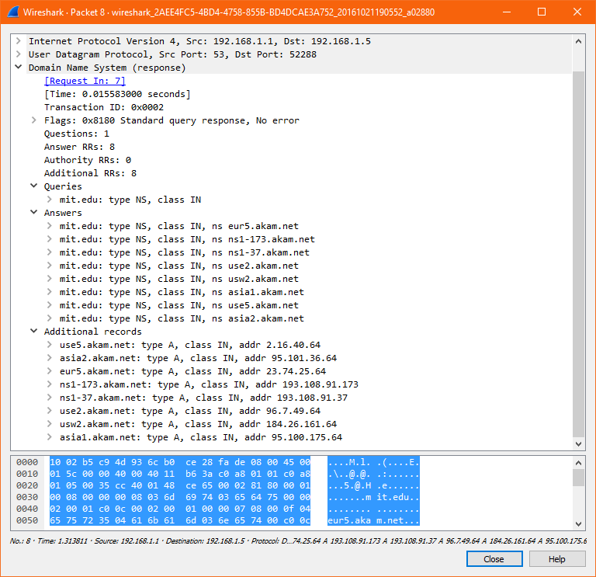

**In addition, the IP addresses of the nameservers are also provided:**



1. Provide a screenshot.

